# Hornet Indicators

Last Update 1 Jan 2019

The Hornet Indicators provides an interface between VRS Simulations Superbug and physical display panels.

The Arduino code is owned by Glenn Weston and interfaces closely with Glenn’s Superscript. It is hosted on <http://hornetpits.org/index.php?topic=501.0>.

The solution has been engineered to use Network connectivity which provides a level of isolation from the Computers USB bus. This does require an additional network card[1] and some configuration on the PC running Superscript. Data is delivered on a UDP transport, which provides a high level of isolation, enabling the Hornet Indicators solution to be restarted or powered off without impacting the primary computer.

The original deployments of this solution are powered by a USB hub (which does not need to be connected to the computer). The October build utilises a local 12V to 5V regulator, so now only 12V plug pack is needed to operate the solution. Another simple option is to use a USB charger such as one that is used to charge a phone. The major consideration is that the charger is able to supply 5V at least 1 Amp (i.e. 5Watts). By powering the Arduino off either a separate USB hub or charger, a larger degree of isolation is provided, with the only connectivity to the PC being the network cable which provides a higher degree of isolation than a USB cable.

## Configuration Steps

Edit the Superscript configuration file to enable the export modules of interest. Originally the BITS Go/NO-GO and Spin section was not used, however this has been added in October 2017. In testing the config file was manually edited, but should check out SSConfigEditor and see if values are there.

Note the default values in the Arduino code now have a new IP address, given it is preferable to align setting as close as possible across environments it is recommended to use the new default code setting, which is 192.168.0.210. Previously the Arduino may have lived at (192.168.200.12 or 10.10.0.150)

For each lamp set of interest, it needs to been enabled, with a target IP address configured. The target IP address should be 192.168.0.210

The IP address of the dedicated network interface card in the PC should be

IP Address: 192.168.0.10

Subnet Mask 255.255.255.0

Default Gateway: Not configured

You do not need to reconfigured the primary network interface card.

## Installation and Maintenance

It is very important that no cables should be inserted or removed while power is applied. This could damage the electronics.

All cables are labelled. The one exception is the orange painted connector on the power panel, this is for the 12V gear handle lamp only. DO NOT plug any led indicator into the orange connector, this will destroy the led indicator.

## System Operations

As soon as power is applied the system will progressively flash indicators, from Port to Starboard, and then flash all indicators together.

If no telemetry is received from Superscript, the lights will extinguish.

## Trouble Shooting

The Hornet Indicators is designed to be highly reliable. No maintenance is needed.

If the indicators are not working

1: Check power is being supplied to the 12V to USB 5V converter. There should be a small red light behind the USB output port. If it is not lit, check the power pack is correctly plugged in.

2: Check the Arduino USB port is connected to the 12V to USB 5V convertor. Both the Arduino itself and the Ethernet shield should have a solid red light.

3: Check the Ethernet (network) cable is plugged into the Ethernet Shield. Note the Ethernet Shield Yellow and Green LEDs can be on even if a cable is not plugged it.

4: Ping the solution (from the command prompt ‘ping 192.168.0.210’). there should be 5 responses and no timeout messages.

Advanced Troubleshooting

1: Enable the exercises in superscript for the lamp sets of interest.

2: Install the Arduino Development environment – and use the Tools Serial Monitor (need to select the device that the Arduino appears as. The code has the rate as 115200 baud.

It should trigger a reset and the following should appear -

[2]VRS_Annunciators_7219_V103_PT102

192.168.200.12

Self Test Starting

Self Test Complete

## Builder Notes

Originally sketches would not load due to the system not correctly resetting when the network shield was installed.

This is a known issue with a fix described at <https://forum.arduino.cc/index.php?topic=99880.15>

It is addressed by removing the capacitor next to the reset button on the Ethernet shield, modified cards have a yellow dot to indicate the board has been modified.

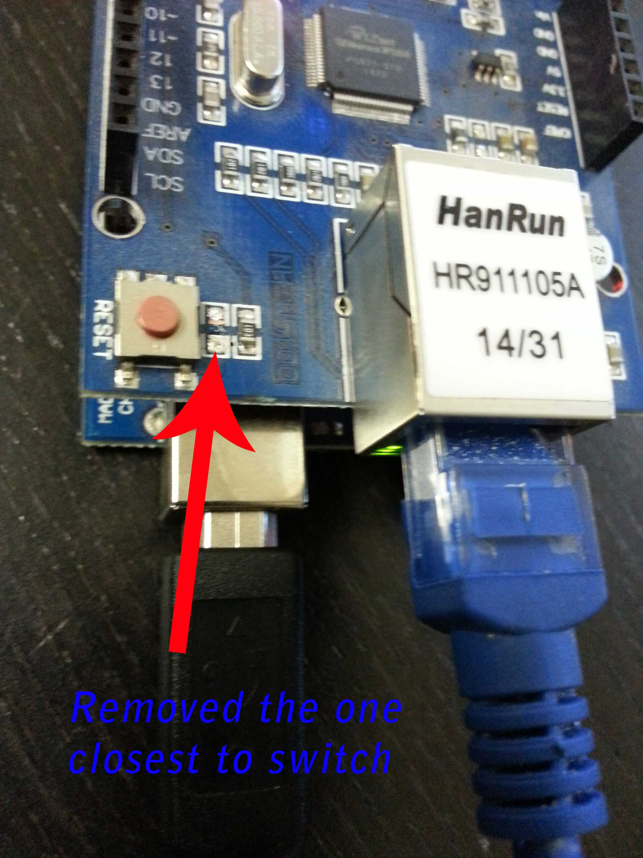

High Level Design

The design is based around an Arduino Uno, an Arduino Ethernet Shield and a Max7219 LED driver.

The original builds had all connectivity to the panels coming from a single PCB. The later build required a relay to drive the gear handle indicator, and an additional breakout board. The additional breakout was needed as the new style eyebrow panels are hand wired, meaning that the panels that used to extend from the eyebrow panels now need to be connected from the central electronics block. New lamps where also added (Bits GO/No-GO, and the spin recovery).

The ROW order on the Led Breakout PCB is labelled incorrectly in this photo. It is actually 1 -7 and then Row 0 on the far right.

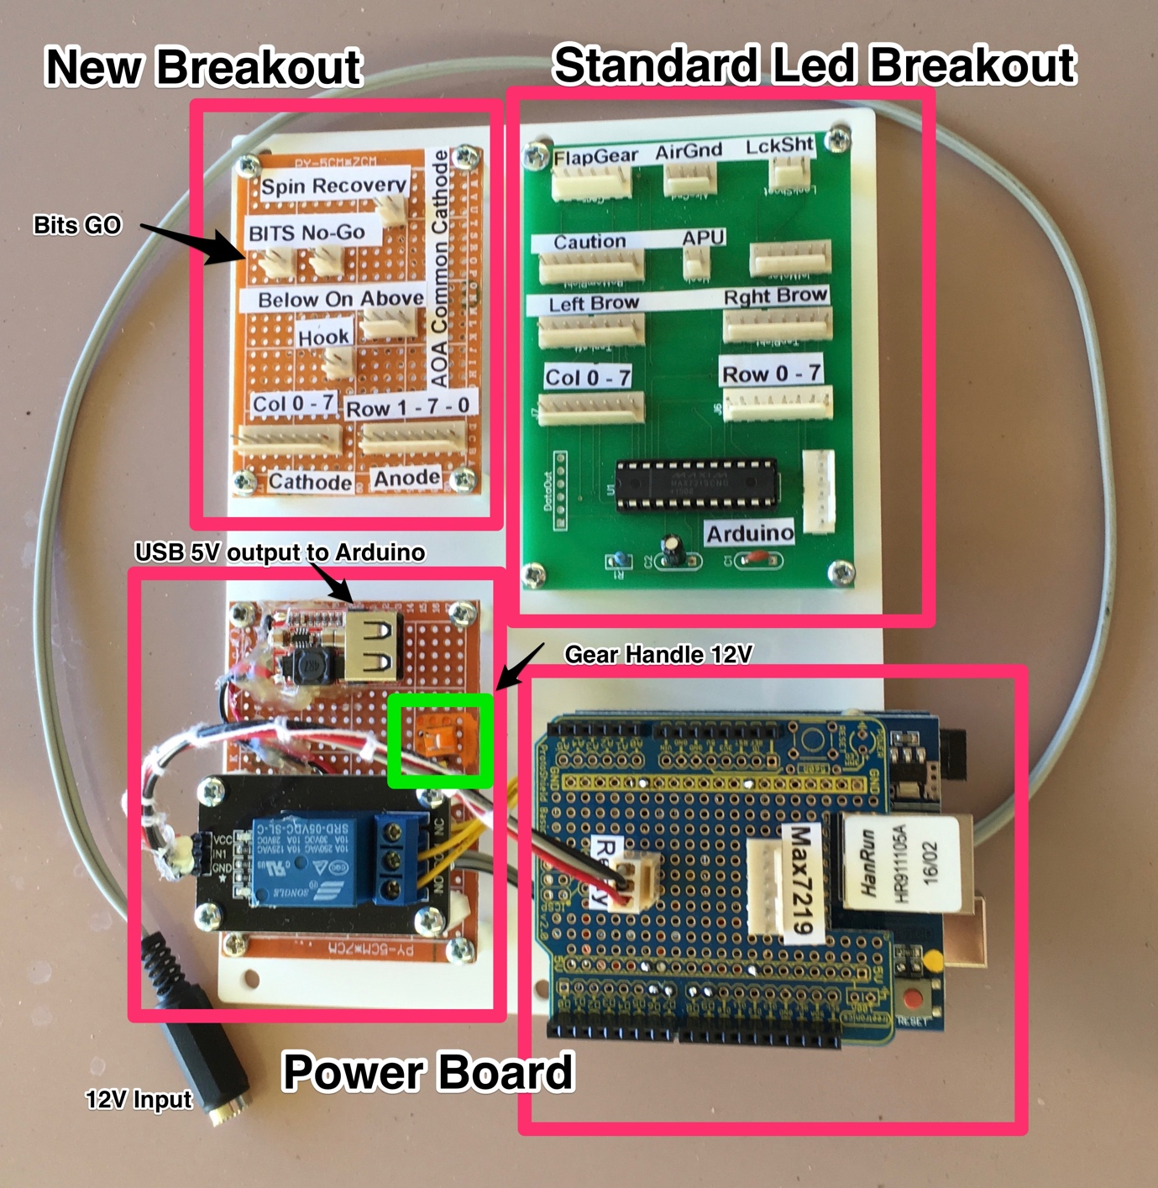

The AOA port on the breakout panel has a Common Cathord.

## Port Allocations

"MASTER CAUTION" COLUMN = 3; ROW = 3

"APU FIRE" COLUMN = 7; ROW = 3

"LEFT ENGINE FIRE" COLUMN = 2; ROW = 2

"RIGHT ENGINE FIRE" COLUMN = 7; ROW = 2

"EXT READY" COLUMN = 6; ROW = 5

"EXT DISCH" COLUMN = 6; ROW = 4

"CTR" COLUMN = 4; ROW = 7

"LI" COLUMN = 5; ROW = 6

"RI" COLUMN = 5; ROW = 7

"LM" COLUMN = 6; ROW = 6

"RM" COLUMN = 6; ROW = 7

"LO" COLUMN = 7; ROW = 6

"RO" COLUMN = 7; ROW = 7

"COM1" COLUMN = 0; ROW = 0

"COM2" COLUMN = 0; ROW = 1

"L BLEED" COLUMN = 0; ROW = 2

"R BLEED" COLUMN = 0; ROW = 3

"SPDBRK" COLUMN = 1; ROW = 0

"BLANK 0" COLUMN = 1; ROW = 1

"L BAR GRN" COLUMN = 1; ROW = 2

"BLANK 1" COLUMN = 1; ROW = 3

"L BAR RED" COLUMN = 2; ROW = 0

"BLANK 2" COLUMN = 2; ROW = 1

"BLANK 3" COLUMN = 2; ROW = 3

"CK SEAT" COLUMN = 2; ROW = 7

"APU ACC" COLUMN = 2; ROW = 6

"BATT SW" COLUMN = 2; ROW = 5

"FCS HOT" COLUMN = 2; ROW = 4

"GEN TIE" COLUMN = 1; ROW = 7

"BLANK 4" COLUMN = 1; ROW = 6

"FUEL LO" COLUMN = 1; ROW = 5

"FCES" COLUMN = 1; ROW = 4

"CK ECS" COLUMN = 0; ROW = 7

"L GEN" COLUMN = 0; ROW = 6

"R GEN" COLUMN = 0; ROW = 5

"BLANK 5" COLUMN = 0; ROW = 4

"BLANK 6" COLUMN = 4; ROW = 0

"BLANK 7" COLUMN = 4; ROW = 1

"REC" COLUMN = 4; ROW = 2

"DPLY" COLUMN = 4; ROW = 3

"JAM ON" COLUMN = 5; ROW = 0

"AI" COLUMN = 5; ROW = 1

"DCOY ON" COLUMN = 5; ROW = 2

"AAA" COLUMN = 5; ROW = 3

"CW" COLUMN = 6; ROW = 0

"SAM" COLUMN = 6; ROW = 1

"MISSILE" COLUMN = 6; ROW = 2

"LOCK" COLUMN = 4; ROW = 6

"SHOOT" COLUMN = 3; ROW = 6

"AA" COLUMN = 7; ROW = 5

"AG" COLUMN = 7; ROW = 4

Gear Handle for standard builds

"GEARHANDLE" COLUMN = 7; ROW = 1;

Gar Handle for gear handles with 12V lights. Uses output port via relay

int GearRelayOutputPort = 6;

"GEARHANDLE" digitalWrite(GearRelayOutputPort, LOW);

"GEARNOSE" COLUMN = 3; ROW = 4

"GEARLEFT" COLUMN = 4; ROW = 4

"GEARRGHT" COLUMN = 3; ROW = 5

"FLAPWARN" COLUMN = 4; ROW = 5

"FLAPHALF" COLUMN = 5; ROW = 4

"FLAPFULL" COLUMN = 5; ROW = 5

"AOAABOVE" COLUMN = 3; ROW = 0

"AOAON" COLUMN = 3; ROW = 2

"AOABELOW" COLUMN = 3; ROW = 1

"HOOK" COLUMN = 7; ROW = 0

"APU READY" COLUMN = 6; ROW = 3

"GO" COLUMN = 7; ROW = 1

"NOGO" COLUMN = 3; ROW = 7

"SPIN" COLUMN = 6; ROW = 3

1. Whilst a secondary IP address could be used on the Computers Primary Network interface, this introduces additional troubleshooting steps.
2. Need to validate this as of 2019